FRONT-END DEVELOPMENT

HACKATHON
Level-1 Template

STUDENT NAME: PRADEESH M
YEAR: 2 nd
COLLEGE CODE: 323
COLLEGE NAME: VOORHEES COLLEGE
DEPARTMENT: B.Sc COMPUTER SCIENCE
SEMESTER: 4 th
ROLL NO: 32324U18031
NMID: 5c4326be76825e887bb417cbbbb1d253
DATE: 13/03/2026
TITLE: STUDENT ACTIVITY TRACKER WEB APPLICATION

1. Use Case and Assumptions

Students often participate in learning activities such as coding practice, assignments, mini projects, and technical exercises. Managing these tasks manually can be difficult and unorganized. A simple web application can help students track their activities and monitor their learning progress easily.
This project assumes that students need a lightweight tool that runs directly in a browser without requiring any backend server or database. The system assumes that activities are predefined and stored directly in the webpage. Users can mark activities as completed, and the progress will update automatically.

2. Problem Statement

Many students struggle to keep track of their learning activities and progress during training programs or academic courses. Existing tools are often complex and require backend configurations. The goal of this assignment is to apply CSS styling and JavaScript functionality to transform a basic HTML page into a clean, interactive, and professional-looking Student Activity Tracker interface.

3.Objective

The main objective of this project is to design and implement a lightweight Student Activity Tracker using only front-end technologies. The application should allow students to view activities, update their completion status, and track overall progress in a simple and user-friendly interface.

4. Key Features
The Student Activity Tracker provides several important features to help users track their activities effectively 4.1 Home Page

The application includes a simple home page with a clear title “Student Activity Tracker” and a welcome message. This section introduces the purpose of the application and provides easy navigation for users.

4.2 Activity List View

The system displays a table containing a list of learning activities. Each activity includes the following details:

- Activity Name – Name of the learning task

- Short Description – A brief explanation of the activity

- Current Status – Indicates whether the activity is Pending or Completed

This structured list allows students to clearly see what tasks need to be completed.

4.3 Mark Activity as Completed

The system displays a table containing a list of learning activities. Each activity includes the following details:
- Activity Name – Name of the learning task
- Short Description – A brief explanation of the activity
- Current Status – Indicates whether the activity is Pending or Completed
This structured list allows students to clearly see what tasks need to be completed.

4.4 Progress Summary
The application includes a progress tracking system that shows how many activities have been completed.
Example:
“2 out of 4 activities completed”
A visual progress bar also updates dynamically to represent the percentage of completed activities.

4.5 Navigation
A navigation menu is included at the top of the page with links such as:
- Home
- Activities
- Progress
This helps users easily move between different sections of the application.

5. UI and Usability Considerations

The application focuses on creating a clean and user-friendly interface.
Key design considerations include:
- Simple and readable typography using Arial font
- Consistent spacing and alignment across elements
- Color-coded status indicators (Red for Pending, Green for Completed)
- Responsive table layout for activity display
- Interactive buttons with hover effects
- Progress bar visualization for better user understanding
These design elements improve usability and overall user experience.

6. Technology Used

The following technologies were used to build this project:
- HTML – Used to create the structure of the webpage
- CSS – Used to style the interface and improve the visual design
- JavaScript – Used to add interactivity such as updating activity status and tracking progress
These technologies allow the application to run directly in a web browser without any backend system.

7. Data Handling Method
The activity data in this project is handled using static data embedded directly in the HTML table. JavaScript is used to dynamically update the activity status and progress when users interact with the application.
No external database or server is required, making the system simple and easy to implement.

8. High-Level UI Flow / Wireframe

The application follows a simple UI flow:
User Opens Application
↓
Home Page Displays Title and Navigation
↓
User Views Activity List
↓
User Clicks Complete Button for an Activity
↓
Activity Status Changes to Completed
↓
Progress Counter and Progress Bar Update
↓
User Can Reset Progress if Needed
This simple flow ensures that users can easily track and update their activities.

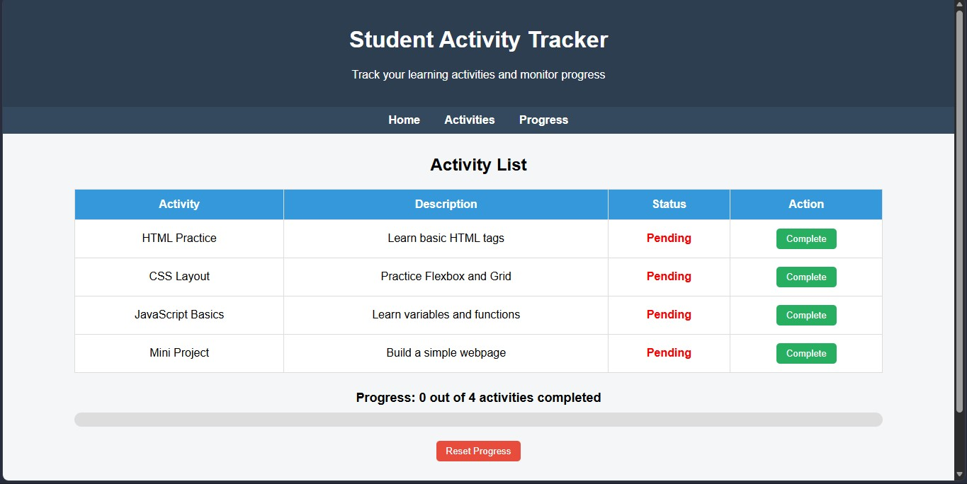

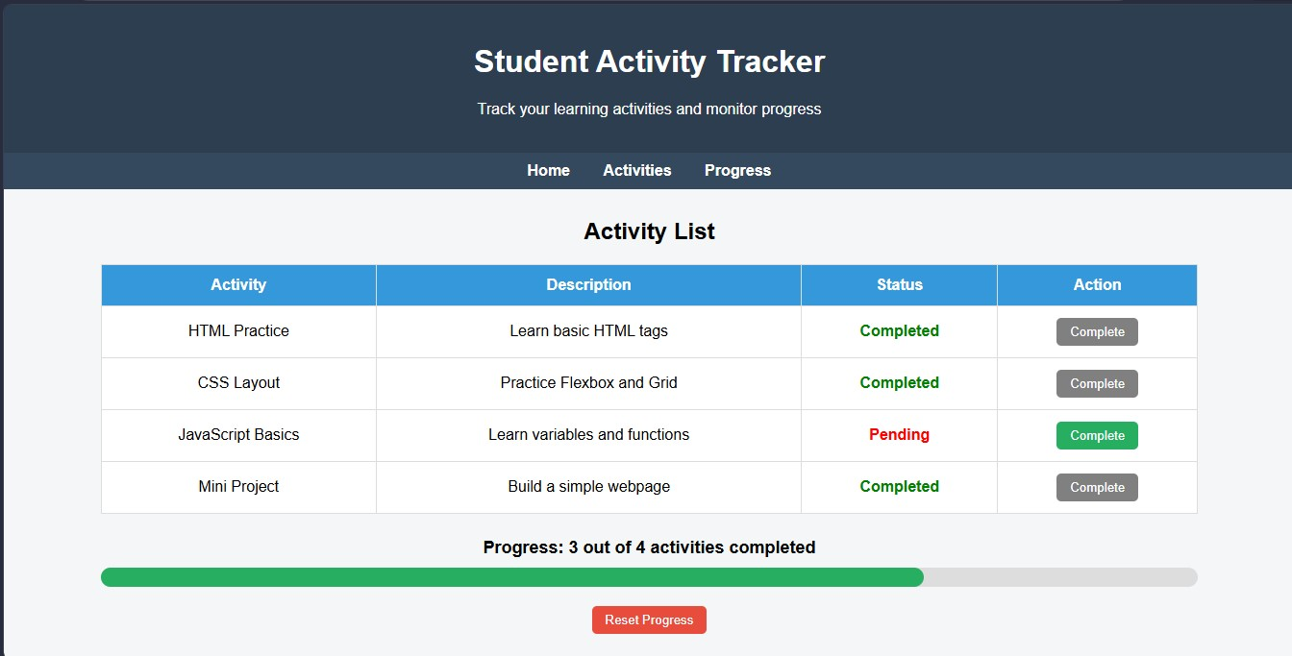

9. Implementation Approach

The implementation of the Student Activity Tracker follows a structured approach:
- HTML Structure
The basic layout includes header, navigation menu, activity table, progress section, and footer.
- CSS Styling
CSS is used to style the layout, tables, buttons, colors, and progress bar to create a professional appearance.
- JavaScript Functionality
JavaScript functions handle:
o Updating activity status o Increasing the completed count o Updating the progress bar o Resetting the tracker
These components work together to create an interactive web application.

10. Expected Outcome
After implementation, the final system will allow students to:
- View their list of learning activities
- Mark activities as completed
- Monitor their learning progress
- Reset progress when needed
The application will be simple, responsive, and easy to use.

11. Learning Outcome

Through this project, the following skills are developed:
- Understanding HTML page structure
- Applying CSS for UI design
- Implementing JavaScript interactivity
- Creating dynamic progress indicators
- Designing user-friendly interfaces
This project helps beginners gain practical experience in front-end development.

12. Conclusion
Through this project, the following skills are developed:
- Understanding HTML page structure
- Applying CSS for UI design
- Implementing JavaScript interactivity
- Creating dynamic progress indicators
- Designing user-friendly interfaces
This project helps beginners gain practical experience in front-end development.

